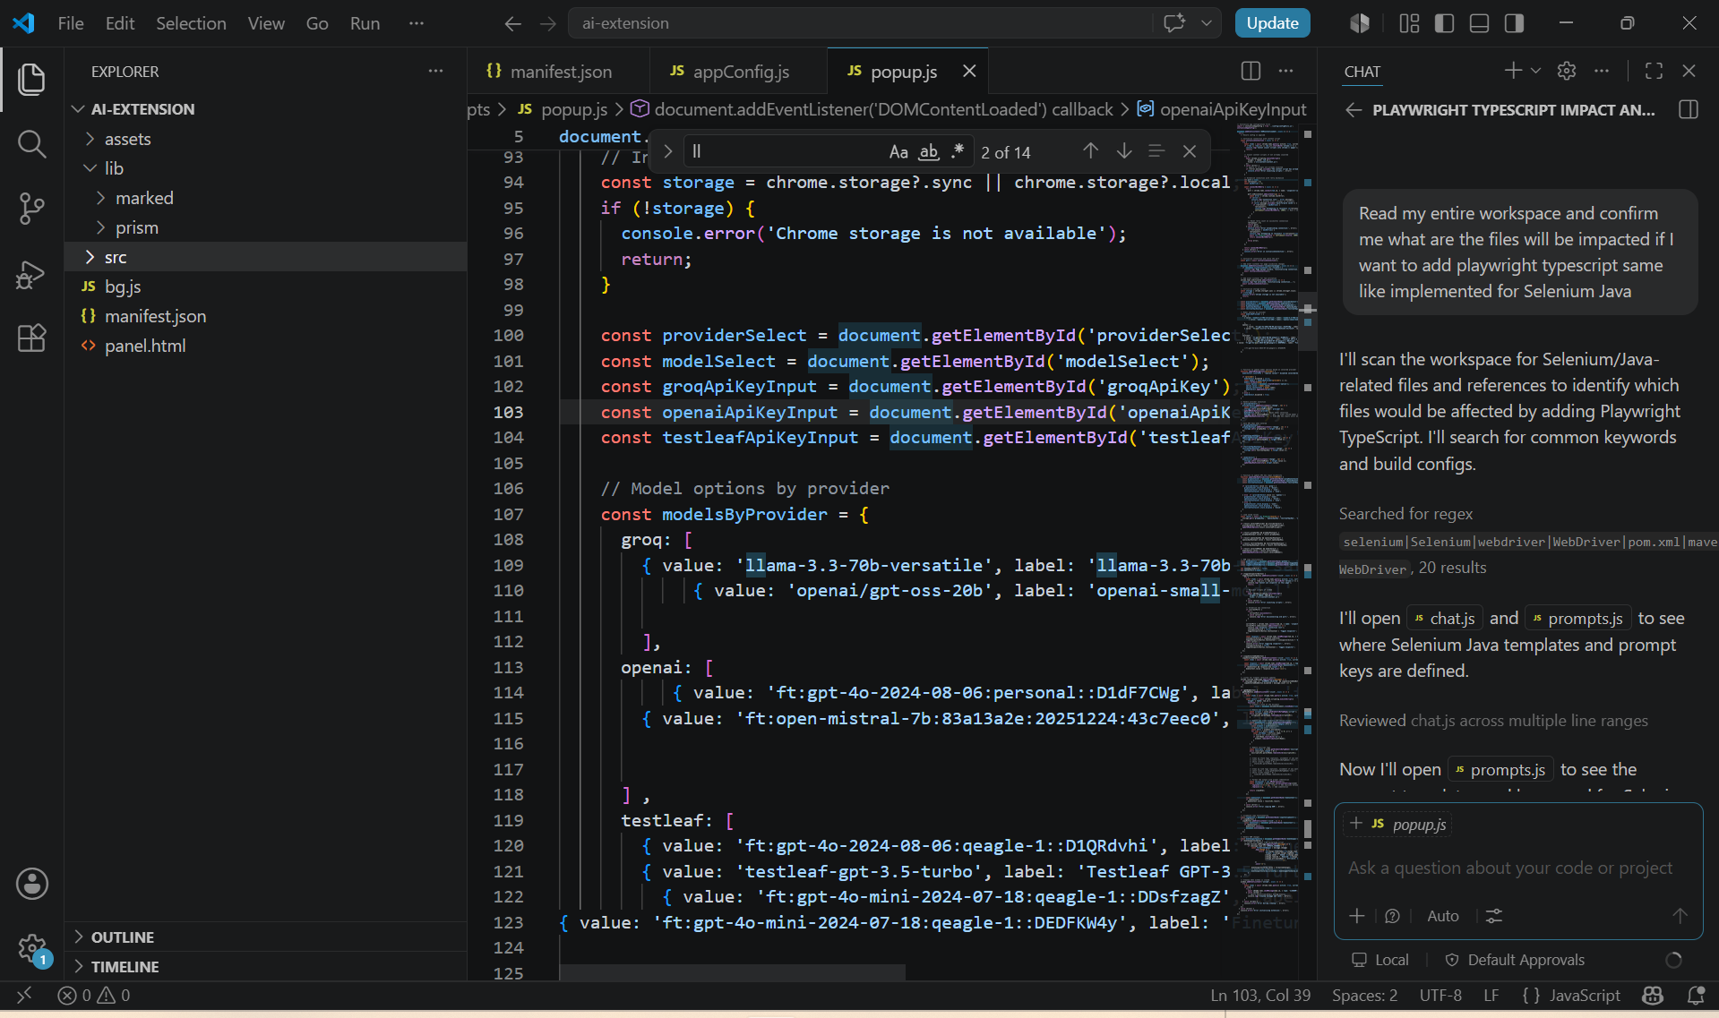
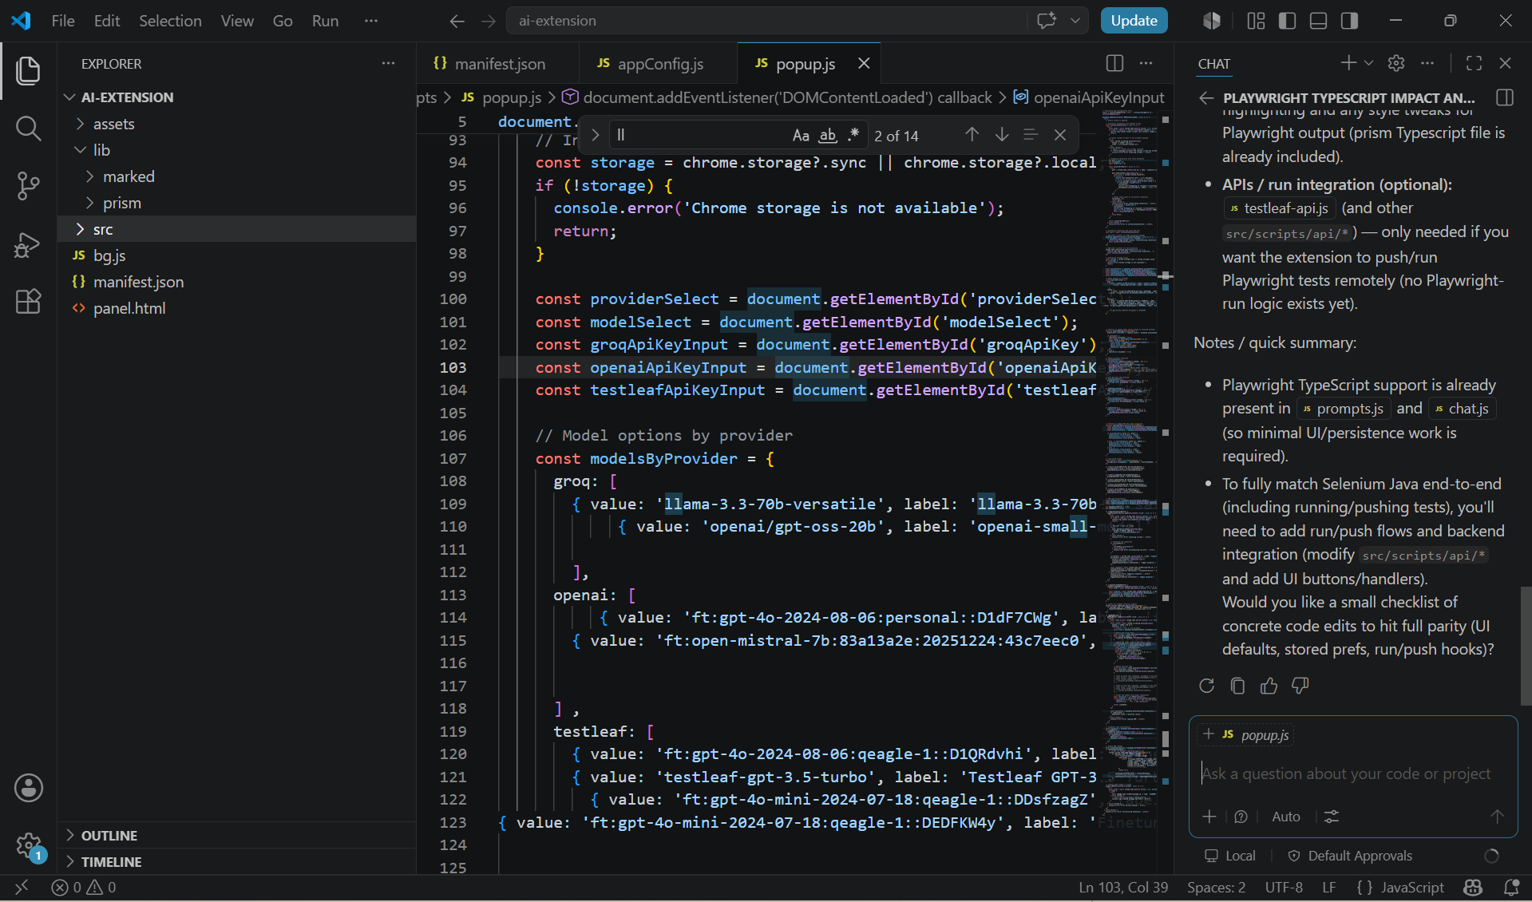
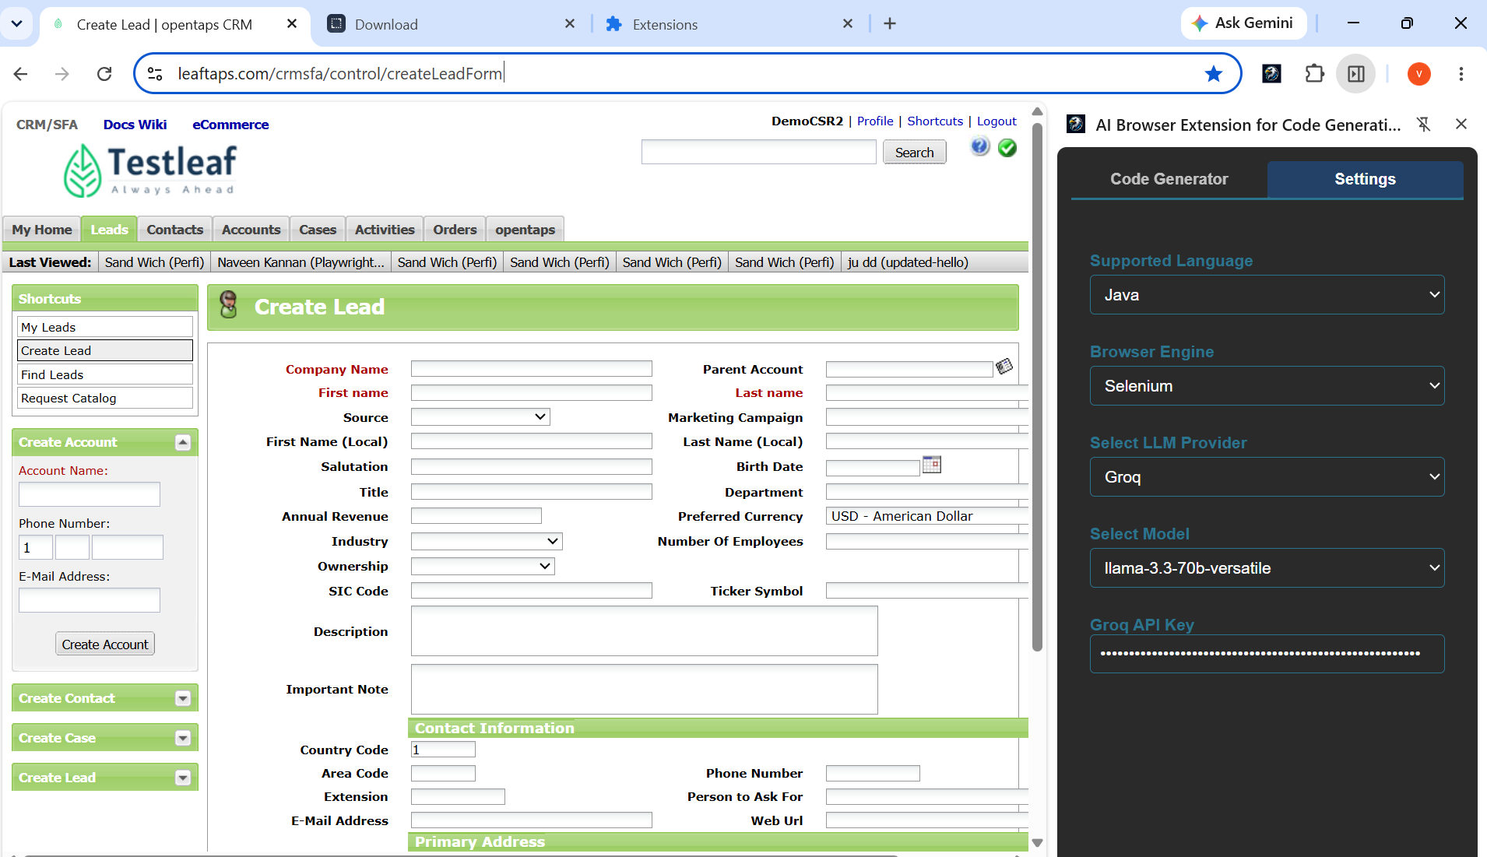
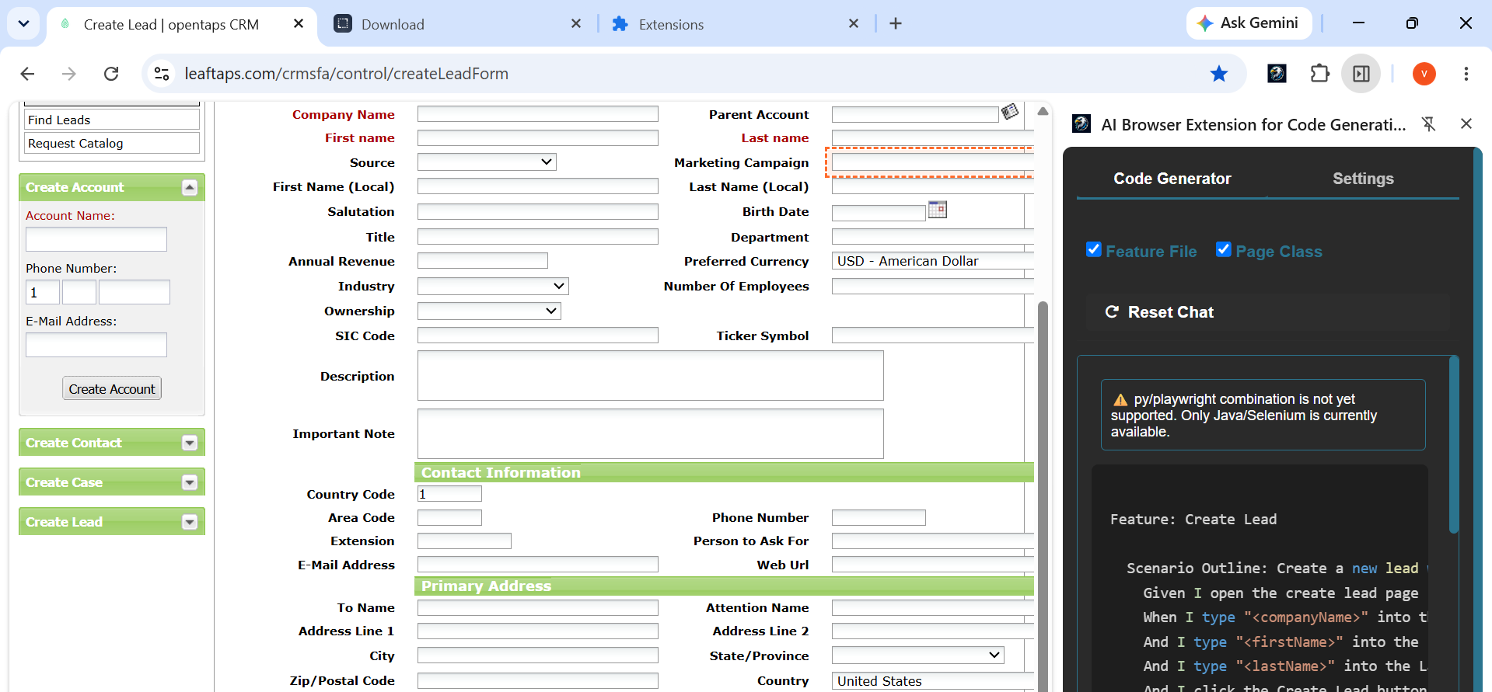

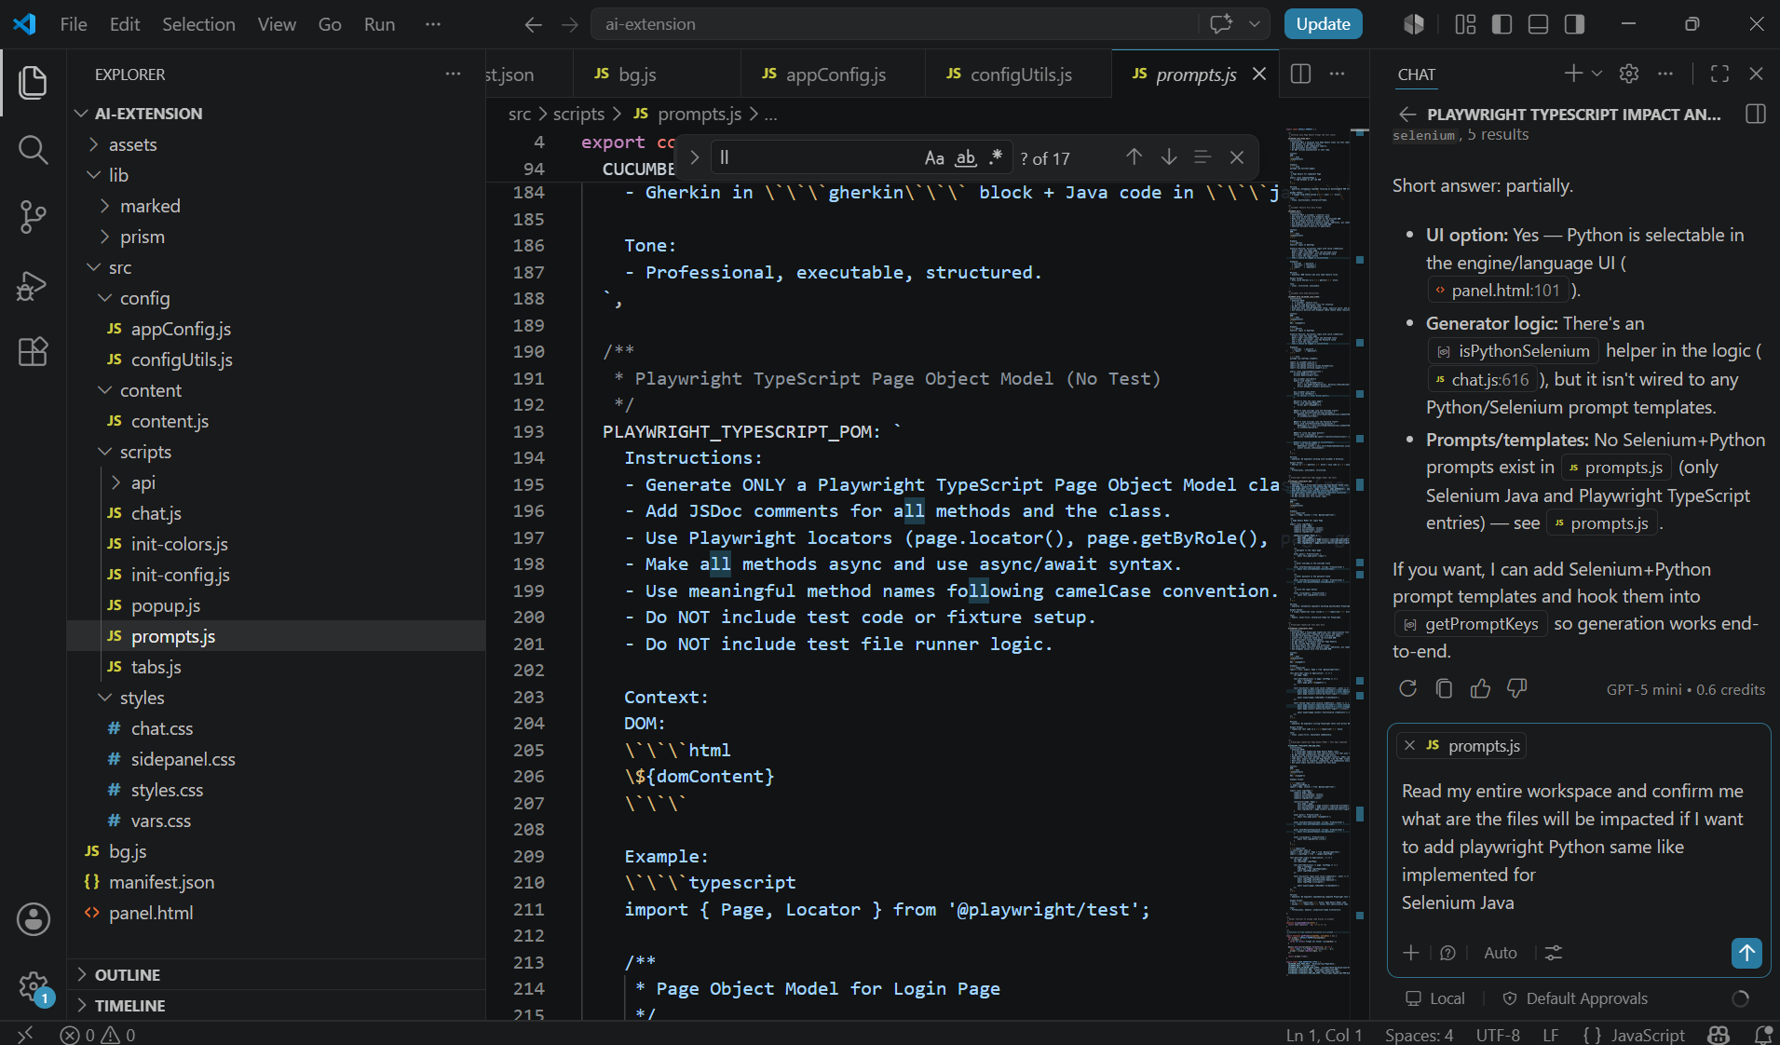
I'll search the repo for Selenium and Playwright references to produce a precise list of files to update.
Plan — steps to add Playwright (Python) parity:
- Add Playwright+Python prompt templates (POM, spec, combined).
- Add generator keys to CODE_GENERATOR_TYPES.
- Wire detection & key mapping in the generator (chat.js).
- Verify UI persistence and highlighting; add run/push hooks only if you want execution.
Files that will be impacted
- UI: panel.html — browser engine & language selects live here (Python + Playwright options already present; verify labels/defaults).
- Prompts: prompts.js — add PLAYWRIGHT_PYTHON_* templates (POM, spec, POM+spec) and update CODE_GENERATOR_TYPES.
- Generation logic: chat.js — add a Playwright+Python detection helper (e.g. isPythonPlaywright(language, engine)), update getPromptKeys() to push the new prompt keys, and ensure the UI label / codeGeneratorType handling covers the new keys.
- Settings/persistence: popup.js — confirm languageBinding (py) and browserEngine (playwright) selections are saved and loaded correctly; adjust if you want a different default for Playwright+Python.
- Syntax highlighting: prism.js / prism-typescript.js — Python highlighting is already supported via py→python mapping; no change usually needed.
- APIs / run integration (optional): testleaf-api.js, openai-api.js, groq-api.js — modify or add endpoints if you want the extension to push/run Playwright Python tests (current code has no Playwright-run flow).
- Config/styles (likely no change): configUtils.js, src/styles/*.
Optional additions if you want full parity with Selenium Java (push/run):
- Add a runner integration and UI handlers (e.g. new runPlaywright() in chat.js or a separate src/scripts/run-playwright.js) and wire it to runTestButton / pushAndRunButton. Update API clients if tests must be executed remotely.
If you want, I can:
- Add the PLAYWRIGHT_PYTHON_* prompt templates in prompts.js and update chat.js to map py + playwright to those templates. Proceed?

Read the Entire workspace and understand how I implemented the selenium Java as I want to add the playwright with Python. I have given in 3 steps below and let me know your analysis and ensure no impact on the existing code function.

1.Go to prompts.js and add new prompt templates for Playwright Python
Take selenium Java as reference

PLAYWRIGHT_PYTHON_PAGE_ONLY
PLAYWRIGHT_PYTHON_WITH_CUCUMBER
CUCUMBER_WITH_PLAYWRIGHT_PYTHON_STEPS

2 .Go to chat.js

Update getPromptKeys() method to handle Playwright/Python combinations

3.Go to panel.html

Add the logics to handle playwright Python same like selenium Java

Reviewing the Selenium Java implementation and its wiring so I can compare it to the proposed Playwright Python changes.
Analysis
I reviewed the relevant files for your extension and confirmed how Selenium Java is implemented.
Key findings
- prompts.js
  - Contains the prompt template definitions.
  - Has Selenium Java prompts: SELENIUM_JAVA_PAGE_ONLY, CUCUMBER_WITH_SELENIUM_JAVA_STEPS.
  - Has Playwright TypeScript prompts, but no Playwright Python prompts.
- chat.js
  - getPromptKeys(language, engine) drives prompt selection based on:
    - selected checkboxes (FEATURE, PAGE)
    - languageBinding value
    - browserEngine value
  - Currently supports:
    - Java + Selenium
    - TypeScript + Playwright
  - Python + Playwright is currently unsupported and falls into the generic unsupported branch.
  - panel.html values are read directly by chat.js via languageBindingSelect.value and browserEngineSelect.value.
- panel.html
  - Already has Python as <option value="py">Python</option>.
  - Already has Playwright as <option value="playwright">Playwright</option>.
  - So the UI already supports selecting Playwright + Python.
  - There is no additional panel-specific code required for the combo beyond the select options.
Your proposed steps
- Add prompt templates in prompts.js
  - Yes, this is the correct place.
  - Use Selenium Java templates as a reference.
  - Add:
    - PLAYWRIGHT_PYTHON_PAGE_ONLY
    - PLAYWRIGHT_PYTHON_WITH_CUCUMBER
    - CUCUMBER_WITH_PLAYWRIGHT_PYTHON_STEPS
- Update chat.js
  - Yes, update getPromptKeys() to handle py + playwright.
  - Add a helper like:
    - isPythonPlaywright(language, engine) { return language === 'py' && engine === 'playwright'; }
  - Add branches:
    - page-only → PLAYWRIGHT_PYTHON_PAGE_ONLY
    - feature-only → PLAYWRIGHT_PYTHON_WITH_CUCUMBER
    - both → CUCUMBER_WITH_PLAYWRIGHT_PYTHON_STEPS
  - Also update the default fallback branch so it uses Python/Playwright when no checkbox is selected.
- Update panel.html
  - No real logic change is needed there if you are only exposing language and engine selectors.
  - The current HTML already supports the Playwright/Python combination.
  - The only change would be if you want to add a dedicated label, instruction text, or a special default.
Impact on existing code
This can be done with minimal impact if implemented cleanly.
- prompts.js additions are isolated and won’t affect existing Selenium Java or Playwright TypeScript behavior.
- chat.js changes are localized to getPromptKeys() and a new helper function.
- panel.html does not need functional changes beyond possibly clarifying the UI.
One caution
addUnsupportedLanguageMessage() currently says:
Only Java/Selenium is currently available.
If you add Playwright Python support, update that message so it no longer incorrectly claims only Java/Selenium is supported.
Conclusion
Yes, your 3-step plan is valid and low-risk:
- add prompt templates in prompts.js
- extend chat.js prompt-key logic
- no extra engine-specific logic is needed in panel.html beyond the existing selectors
If you want, I can now make these exact code changes and keep the current Selenium Java behavior unchanged.
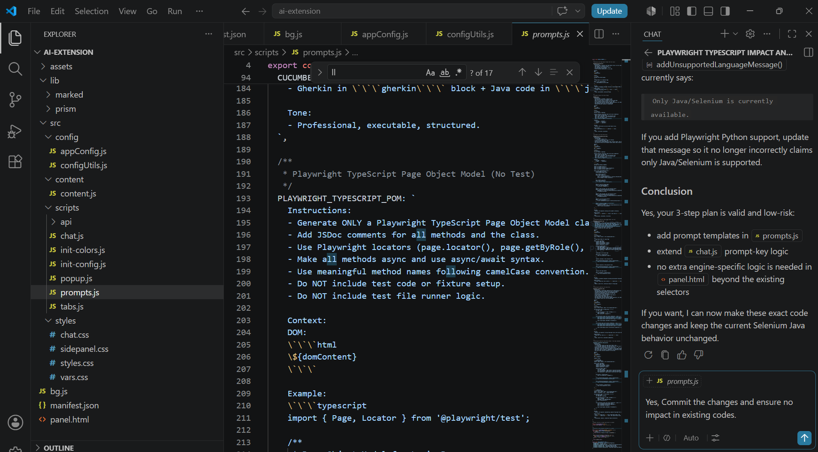
I’m verifying the exact prompt file sections and chat-key branch to patch safely without breaking existing behavior.
Applying Playwright Python prompt templates and mapping logic while preserving existing Java/Selenium behavior.
I’ve made the core updates; now I’m verifying the inserted prompts and chat mappings to confirm everything landed cleanly.
I found the prompt key enum update but the new Playwright Python templates didn’t insert yet; I’m adding them now precisely at the end of DEFAULT_PROMPTS.
I’m inserting the missing Playwright Python prompt blocks at the exact end of the DEFAULT_PROMPTS object.
I’m checking the modified files for syntax or lint issues now.
I’m fixing the new prompt templates so they use escaped backticks and escaped template variables inside the JS template literal.
Reviewing the current inserted prompt blocks to patch the remaining unescaped parts precisely.
Read prompts.js, lines 450 to 632
I’m correcting the final Playwright Python combined prompt block so the JS template literal is syntactically valid.
Verifying the final prompt syntax after escaping the remaining template literals.
Done
✅ I committed the Playwright Python support changes without impacting existing Selenium Java or Playwright TypeScript behavior.
Files changed
- prompts.js
  - Added new prompt templates:
    - PLAYWRIGHT_PYTHON_PAGE_ONLY
    - PLAYWRIGHT_PYTHON_WITH_CUCUMBER
    - CUCUMBER_WITH_PLAYWRIGHT_PYTHON_STEPS
  - Added corresponding CODE_GENERATOR_TYPES entries.
- chat.js
  - Updated getPromptKeys() to handle py + playwright combinations:
    - page-only → PLAYWRIGHT_PYTHON_PAGE_ONLY
    - feature-only → PLAYWRIGHT_PYTHON_WITH_CUCUMBER
    - both → CUCUMBER_WITH_PLAYWRIGHT_PYTHON_STEPS
  - Added isPythonPlaywright() helper.
  - Updated unsupported-message text to reflect supported combos.
Panel UI
- panel.html did not need change because Python and Playwright are already available as selectable options and the generator logic now supports that combo.
Validation
- Checked prompts.js and chat.js for syntax/errors
- No errors found
If you want, I can also add a small comment in panel.html clarifying that Python + Playwright is supported.

Raptor mini (Preview) • 11.1 credits
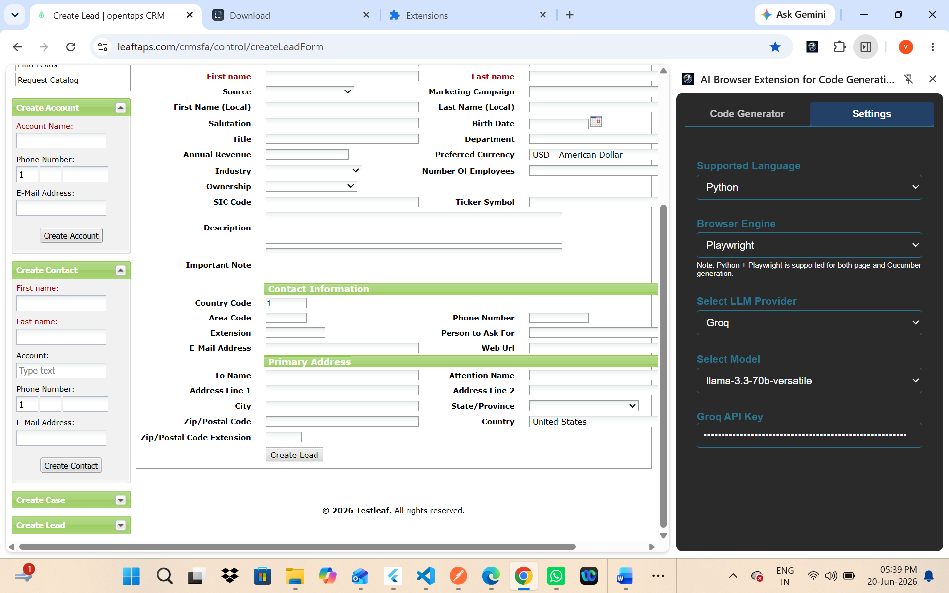
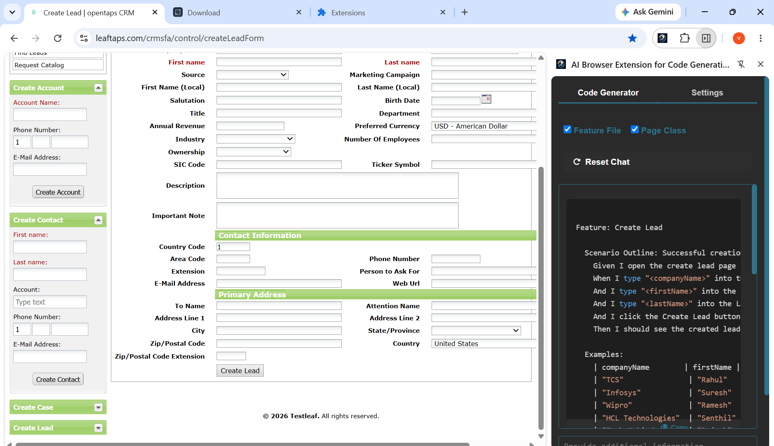
Feature: Create Lead

Scenario Outline: Successful creation of lead with valid details
Given I open the create lead page
When I type "<companyName>" into the Company Name field
And I type "<firstName>" into the First Name field
And I type "<lastName>" into the Last Name field
And I click the Create Lead button
Then I should see the created lead details

Examples:
| companyName | firstName | lastName |
| "TCS" | "Rahul" | "Kumar" |
| "Infosys" | "Suresh" | "Rao" |
| "Wipro" | "Ramesh" | "Naidu" |
| "HCL Technologies" | "Senthil" | "Kumar" |
| "Tech Mahindra" | "Rajesh" | "Reddy" |

from behave import given, when, then
from playwright.sync_api import expect

@given("I open the create lead page")
def open_create_lead_page(context):
context.page = context.browser.new_page()
context.page.goto("https://leaftaps.com/crmsfa/control/createLeadForm")

@when("I type {string} into the Company Name field")
def enter_company_name(context, company_name):
context.page.locator('input[id="createLeadForm_companyName"]').fill(company_name)

@when("I type {string} into the First Name field")
def enter_first_name(context, first_name):
context.page.locator('input[id="createLeadForm_firstName"]').fill(first_name)

@when("I type {string} into the Last Name field")
def enter_last_name(context, last_name):
context.page.locator('input[id="createLeadForm_lastName"]').fill(last_name)

@when("I click the Create Lead button")
def click_create_lead(context):
context.page.locator('input[id="ext-gen524"]').click()

@then("I should see the created lead details")
def verify_lead_creation(context):
expect(context.page.locator('text="Lead Details"')).to_be_visible()
Copy
